Digital Literacy

Submitted by: AARYESH RAHUL THORAT
Registration Number: 25MIP10076

Project Task

Task- 2 - Portfolio

Task 2 Portfolio

Create/update profiles on following 3 platforms;

GitHub
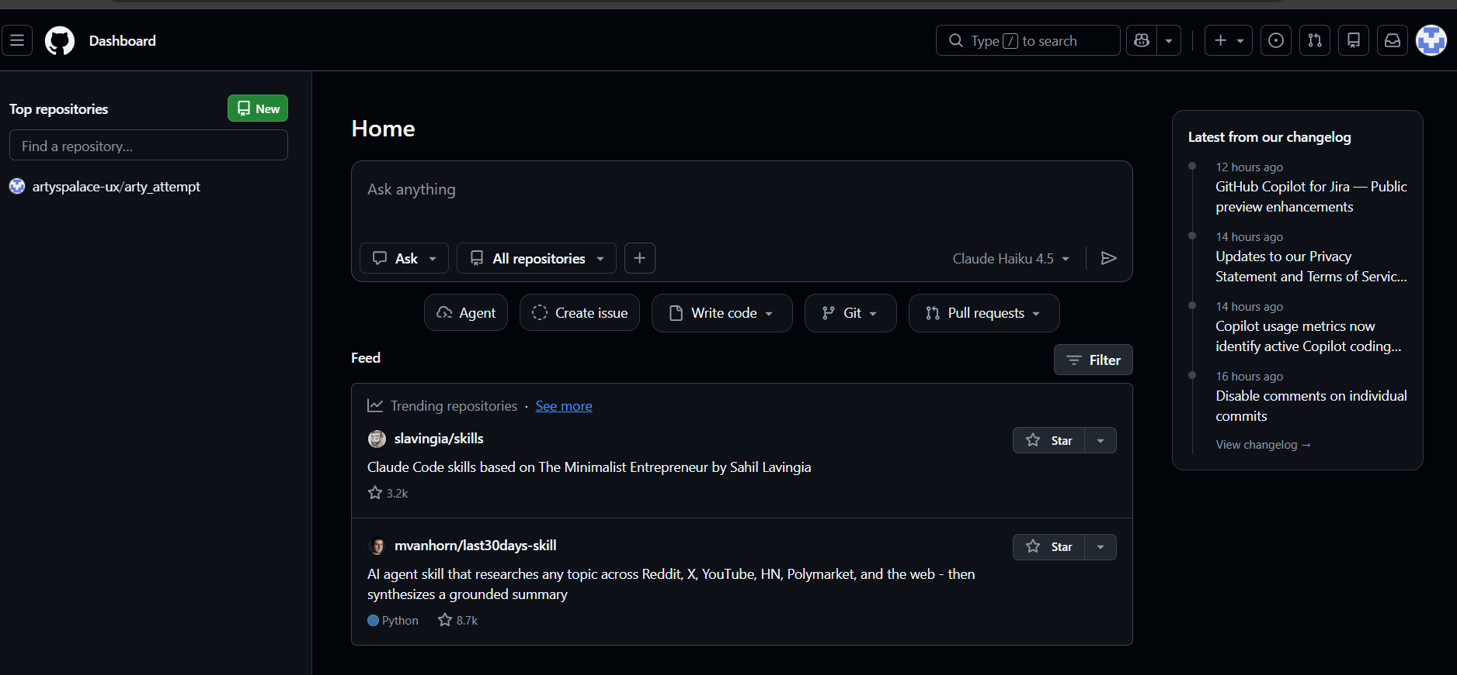

https://github.com/aaryesh25mip10076stack/aaryesh25mip10076stack/graphs/commit-activity

Kaggle

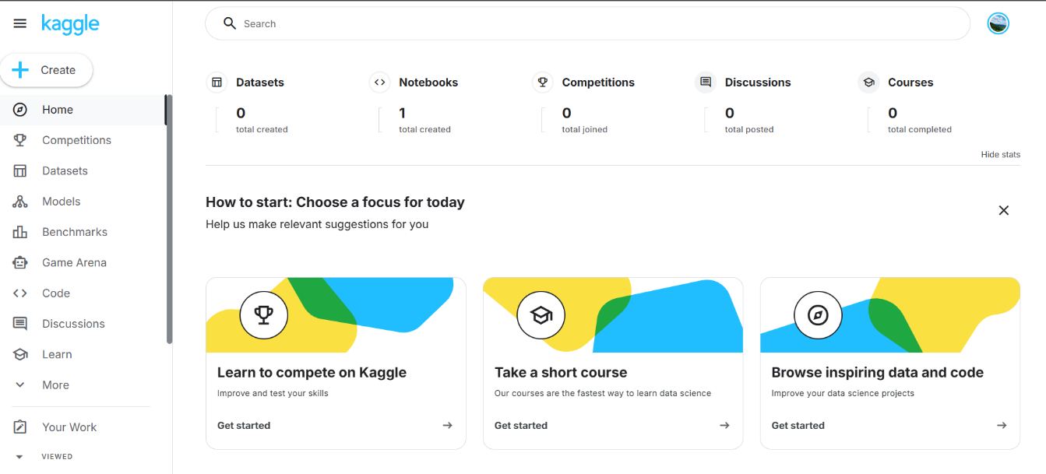
Stack Overflow

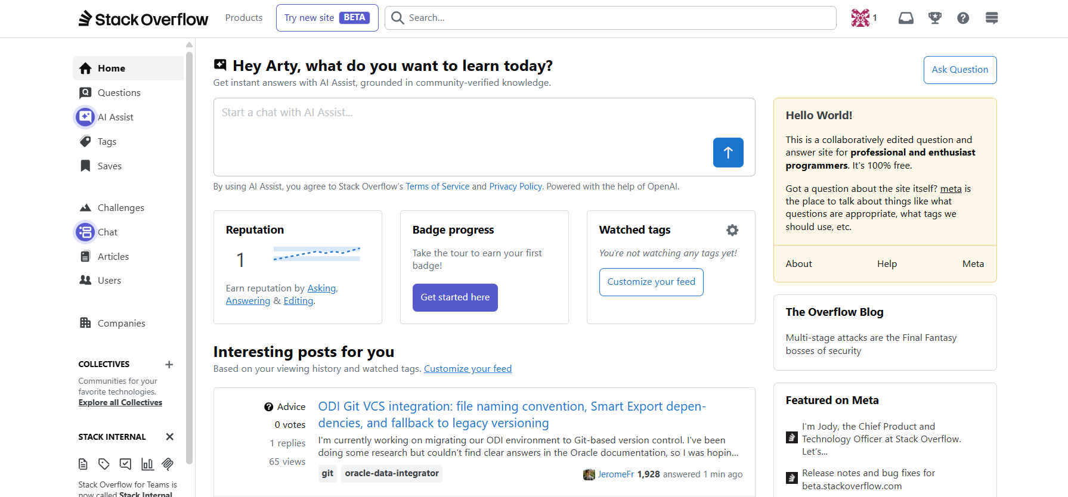

Reflection Report on GitHub , Kaggle & Stack Overflow
For my digital portfolio task, I explored and created profiles on GitHub, Kaggle, and Stack Overflow. These platforms are widely used by students, developers, and data scientists to learn, collaborate, and share their work. GitHub is mainly used for hosting and managing code repositories. I created a profile README that includes my name, branch, and a short description of my learning goals. This platform will help me store my projects and track my progress throughout my studies.
Kaggle focuses on data science and machine learning. It provides datasets, competitions, and notebooks where users can practice data analysis and improve their skills. I plan to use Kaggle to explore different datasets and strengthen my understanding of data science concepts. Stack Overflow is a community-based platform where programmers ask and answer technical questions. It is very helpful when facing coding challenges or trying to learn new programming concepts. Over the next four years, these platforms will help me develop my skills, solve problems more effectively, and build a strong professional digital presence.

